WMRA Athletes Commission

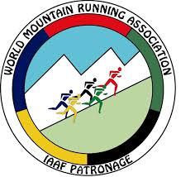

**Nomination Form**

|  |  |
| --- | --- |
| The Federation (Country) of: |  |

|  |  |
| --- | --- |
| Family Name |  |
| First Name |  |
| Date of Birth |  |
| Gender |  |

I declare that:

* I understand and agree to follow the Terms of Reference of the WMRA Athletes Commission
* I have good spoken and written English
* I regularly use email and internet
* I have never been sanctioned for a doping offence
* If I am elected to the Athletes Commission, I agree to fulfil my roles as best possible by being actively engaged and giving valuable input

In the box below please outline why you want to be elected to the WMRA Athletes Commission:

|  |
| --- |
|  |

If I am elected to the WMRA Athletes Commission, I would want to change/improve/make the following proposals:

|  |
| --- |
|  |

Most recent WMRA World Championships in which the Nominee competed:

|  |  |
| --- | --- |
| Classic or Long distance 2018 |  |
| Classic or Long distance 2017 |  |
| Classic or Long distance 2016 |  |
| Classic or Long distance 2015 |  |
| Classic or Long distance 2014 |  |
| Classic or Long distance 2013 |  |
| Classic or Long distance 2012 |  |
| Classic or Long distance 2011 |  |
| Classic or Long distance 2010 |  |
| Classic or Long distance 2009 |  |

Nominee’s signature Date

Please also attach a photo yourself